# VISVESVARAYA TECHNOLOGICAL UNIVERSITY

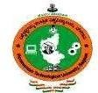**BELAGAVI – 590018, Karnataka**

## INTERNSHIP REPORT

### ON

“Restaurant Website”

***Submitted in partial fulfilment for the award of degree(18CSI85)***

## BACHELOR OF ENGINEERING IN INFORMATION SCIENCE

***Submitted by:***

### ADITHYA J G

### 1JB20IS003



Conducted at

### VARCONS TECHNOLOGIES PVT LTD



**SJB INSTITUTE OF TECHNOLOGY, BENGALURU**

**Department of Information Science and Engineering**

**BGS HEALTH AND EDUCATION CITY, KENGERI, BENGALURU-560060, KARNATAKA, INDIA.**

**SJB INSTITUTE OF TECHNOLOGY**

## Department of Information Science and Engineering

### BGS HEALTH AND EDUCATION CITY, KENGERI, BENGALURU-560060, KARNATAKA, INDIA.



**CERTIFICATE**

This is to certify that the Internship titled **“Restaurant Website”** carried out by **Mr. ADITHYA JG [1JB20IS003],** a bonafide student of SJB Institute of Technology, in partial fulfillment for the award of **Bachelor of Engineering**, in **Information Science** under Visvesvaraya Technological University,Belagavi, during the year 2023-2024. It is certified that all corrections/suggestions indicated have been incorporated in the report.

The project report has been approved as it satisfies the academic requirements in respect of Internship prescribed for the course Internship / Professional Practice (18CSI85)

### Signature of Guide Signature of HOD Signature of Principal

**External Viva:**

Name of the Examiner Signature with Date

1)

2)

# D E C L A R A T I O N

I, **Adithya JG**, final year student of Information Science, SJB Institute of Technology - 560060, declare that the Internship has been successfully completed, in **Varcons Technologies Pvt Ltd**. This report is submitted in partial fulfillment of the requirements for award of Bachelor Degree in Information Science, during the academic year 2023-2024.

Date: 20/09/2023 :

Place: Bengaluru USN: 1JB20IS003

NAME: ADITHYA J G

**OFFER LETTER PROVIDED BY THE COMPANY**

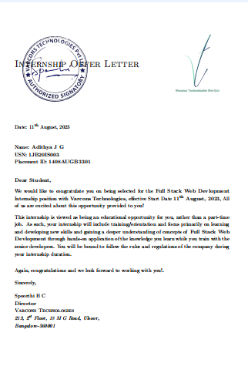

# A C K N O W L E D G E M E N T

This Internship is a result of accumulated guidance, direction and support of several important persons. I take this opportunity to express our gratitude to all who have helped us to complete the Internship.

I express my sincere thanks to our Principal, for providing usadequate facilities to undertake this Internship.

I would like to thank our Head of Department – ISE, for providing us an opportunity to carry out Internship and for his valuable guidance and support.

I express my deep and profound gratitude to our guide, Assistant/Associate Prof, for her keen interest and encouragement at every step in completing the Internship.

I would like to thank all the faculty members of our department for the support extended during the course of Internship.

I would like to thank the non-teaching members of our department, for helping us during the Internship.

Last but not the least, I would like to thank my parents and friends without whose constant help, the completion of Internship would have not been possible.

**ADITHYA J G 1JB20IS003**

# ABSTRACT

This project aims to create an enticing and functional website template tailored for restaurants. The template will prominently feature a visually appealing menu presentation of the restaurant's cuisine. It will include a reservation system that allows users to book tables ensuring a seamless booking experience. The template will implement lazy loading for images to enhance loading times, ensuring a smooth user experience. Additionally, it will incorporate an interactive and mobile- friendly location map, providing users with easy navigation to the restaurant. Overall, this website template will offer a comprehensive solution for restaurants to showcase their offerings and enhance their online presence.

The template will include a gallery section to showcase the restaurant's ambience, decor, and previous dining experiences. This helps potential customers get a sense of the restaurant's atmosphere.

# Table of Contents

|  |  |  |
| --- | --- | --- |
| **Sl no** | **Description** | **Page no** |
| 1 | Company Profile | 8 |
| 2 | About the Company | 10 |
| [3](https://1.bp.blogspot.com/-dODuK8N5h1Q/Wlnyb3V9HFI/AAAAAAAACL4/WxQtCJ1pM5wccDABg4wIrTBUB0vlikXQQCLcBGAs/s1600/poly1.jpg) | Introduction | 14 |
| [4](https://1.bp.blogspot.com/-dODuK8N5h1Q/Wlnyb3V9HFI/AAAAAAAACL4/WxQtCJ1pM5wccDABg4wIrTBUB0vlikXQQCLcBGAs/s1600/poly1.jpg) | System Analysis | 17 |
| [5](https://1.bp.blogspot.com/-dODuK8N5h1Q/Wlnyb3V9HFI/AAAAAAAACL4/WxQtCJ1pM5wccDABg4wIrTBUB0vlikXQQCLcBGAs/s1600/poly1.jpg) | Requirement Analysis | 19 |
| 6 | [Implementation](https://4.bp.blogspot.com/-IOOxgPaXMVc/Wlj3LWvcnjI/AAAAAAAACKE/UeTFYvAxDmUDel5UBjdifeWaApB3-dXVgCLcBGAs/s1600/img1.jpg) | 21 |
| 7 | Snapshots | 23 |
| 8 | Conclusion | 32 |
| 9 | References | 34 |

**[CHAPTER](https://1.bp.blogspot.com/-dODuK8N5h1Q/Wlnyb3V9HFI/AAAAAAAACL4/WxQtCJ1pM5wccDABg4wIrTBUB0vlikXQQCLcBGAs/s1600/poly1.jpg) 1 COMPANY PROFILE**

# COMPANY PROFILE

## A Brief History of Varcons Technologies

Varcons Technologies is a leading provider of cutting-edge technologies and services, offering scalable solutions for businesses of all sizes. They offer smart, innovative services to dozens of clients, develop SaaS products, provide Corporate Seminars, Industrial trainings and much more.

Varcon Technologies is a Technology Organization providing solutions for all web design and development, MYSQL, PYTHON Programming, HTML, CSS, ASP.NET and LINQ.

Varcons Technologies work with their clients and help them todefine their exact solution requirement. They position themselves as an IT solutions consulting group comprising of high caliber consultants.

They believe that Technology when used properly can help any business to scale and achieve new heights of success. It helps Improve its efficiency, profitability, reliability; to put it in one sentence “Technology helps you to Delight your Customers” and that is what we want to achieve.

# [CHAPTER](https://1.bp.blogspot.com/-dODuK8N5h1Q/Wlnyb3V9HFI/AAAAAAAACL4/WxQtCJ1pM5wccDABg4wIrTBUB0vlikXQQCLcBGAs/s1600/poly1.jpg) 2 ABOUT THE COMPANY

1. **ABOUT THE COMPANY**

Varcons Technologies is a Technology Organization providing solutions for all web design and development, MYSQL, PYTHON Programming, HTML, CSS, ASP.NET and LINQ. Meeting the ever increasing automation requirements, Varcons Technologies specialize in ERP, Connectivity, SEO Services, Conference Management, effective webpromotion and tailor- made software products, designing solutions best suiting clients requirements. The organization where they have a right mix of professionals as a stakeholders to help us serve our clients with best of our capability and with at par industry standards.They have young, enthusiastic, passionate and creative professionals to develop technologicalinnovations in the field of Mobile technologies, Web applications as well as Business and Enterprise solution. Motto of the organization is to collaborate with clients to provide them with best Technological solution hence creating good present and better future for the client which will bring a cascading a positive effect in their business shape as well.

## Products of Company

### Android Apps

It is the process by which new applications are created for devices running the Android operating system. Applications are usually developed in Java (and/or Kotlin; or other such option) programming language using the Android software development kit (SDK), but other development environments are also available, some such as Kotlin support the exact same Android APIs (and bytecode), while others such as Go have restricted API access.

The Android software development kit includes a comprehensive set of development tools. These include a debugger, libraries, a handset emulator based on QEMU, documentation, sample code, and zutorials. Currently supported development platforms include computers running Linux (any modern desktop Linux distribution), Mac OS X 10.5.8 or later, and Windows 7 or later.

### Web Application

It is a client–server computer program in which the client (including the user interface and client- side logic) runs in a web browser. Common web applications include web mail, online

retail sales, online auctions, wikis, instant messaging services and many other functions. web applications use web documents written in a standard format such as HTML and JavaScript,which are supported by a variety of web browsers. The use of web application frameworks can often reduce the number of errors in a program, both by making the code simpler, and by allowing one team to concentrate on the framework while another focuses on a specified usecase.

Frameworks can also promote the use of best practices such as GET after POST. There are some who view a web application as a two-tier architecture. The client would handle the presentation tier, the server would have the database (storage tier), and the business logic (application tier) would be on one of them or on both. While this increases the scalability of the applications and separates the display and the database, it still doesn‟t allow for true specialization of layers, so most applications will outgrow this model. An emerging strategy for application software companies is to provide web access to software previously distributed as local applications. Depending on the type of application, it may require the development of an entirely different browser-based interface, or merely adapting an existing application to use different presentation technology.

Security breaches on these kinds of applications are a major concern because it can involve both enterprise information and private customer data. Protecting these assets is an important part of any web application and there are some key operational areas that must be included in the development process. This includes processes for authentication, authorization, asset handling, input, and logging and auditing. Building security into the applications from the beginning can be more effective and less disruptive in the long run.

### Web design

It is encompasses many different skills and disciplines in the production and maintenance of websites. The different areas of web design include web graphic design, interface design, authoring, including standardized code and proprietary software and user experience design.

The term web design is normally used to describe the design process relating to the front-end (client side) design of a website including writing mark up. Web designers are expected to have an awareness of usability and if their role involves creating mark up then they are also expected to be up to date with web accessibility guidelines.

## Services

Varcons Technologies provides a host of services to its customers/users/clients, enabling business success driven by technology harnessing the power of technology, create a measurable difference for our clients across various industries & multiple geographies.

### Website as Software:

They develop websites that behave and interact similar to sophisticated software.

### Search Engine Optimisation:

They help you manage your SEO campaign more efficiently and effectively and help you gain market share by leveraging their expertise.

### Comprehensive Customer Support:

With a comprehensive range of services, they guarantee that technology needs are not just met, but exceeded. They work with customers/users closely to understand the way users/customers use/make use of products/services.

### Branding and Design:

They offer professional Graphic design, Brochure design & Logo design. They are experts in crafting visual content to convey the right message to the customers and also design custom wraps for your products(also known as package designing).

### Analytics and Research:

They analyse the way customers interact with business by gathering, studying and understanding the consumer voice and their perception of the product/service.

### Embedded Systems and IOT:

They work with Consumer Electronics, Lighting, Home Automation, Metering, Sensor- Technology, Home Appliance and Medical Device companies to help clients create smart and connected products. Through its integrated Embedded and IoT services, Varcons technologies helps build intelligent & connected devices that can be remotely monitored and controlled while leveraging edge and cloud computing for a host of intelligent applications and analytics.

# [CHAPTER](https://1.bp.blogspot.com/-dODuK8N5h1Q/Wlnyb3V9HFI/AAAAAAAACL4/WxQtCJ1pM5wccDABg4wIrTBUB0vlikXQQCLcBGAs/s1600/poly1.jpg) 3 INTRODUCTION

1. **INTRODUCTION**

## Introduction to Web Apps

Web applications are similar to the traditional applications you’d install on your Information, such as Microsoft Office. They are able to perform the same kinds of tasks, they look the same and they feel the same but there is one key difference - the application itself is not installed on your phone or Information, but lives in the cloud. Web apps are not new, but it used to be that they were often unable to compete with more traditional applications for business critical functions or where rich user interaction was required. This is no longer the case. With the power of modern web technologies, we are able to design and build performing, secure, and feature rich applications that live in the cloud and bring with them a huge number of benefits.

### They can be accessed from anywhere.

Because web applications are built with web technologies and they run in a web browser Internet Explorer, Google Chrome, Mozilla Firefox – this allows them to be accessed from every web enabled tool. As long as you have an internet connection you can use them. It allows for remote working, it allows for rapid publishing of content, it allows for real time collaboration between teams. If you have web access, you have the ability to access your business tools.

### They are cost effective.

Web applications are cheaper to produce and maintain than traditional applications. No matter how many platforms your business uses (Mac, Linux, Windows) web application build can be used across them all.

### They benefit from more rapid update cycles.

A huge benefit of web applications is that when an update is released, all of your users are immediately using that version. This doesn’t happen with installed applications, especially in large organizations with IT policies that restrict administrator access.

### They are secure.

Web developers have had to become experts in security – the web is a platform designed to share everything with everyone! As such, the types and levels of security included in web applications are often far greater than those seen in traditional applications.

They also benefit from the ability to launch updates in real-time – the application on the servers is the application people are using. The applications on people’s laptops however is the version last installed. And when those laptops get left on a train it’s not a concern, as nothing is stored locally.

### They enable more computing with fewer Information.

Web applications push all of the hard work to the servers, and act as intermediaries between the user interface and the calculations happening behind the scenes. This means you can accomplish terrifyingly complex work on a tablet, or your phone.

We’ve built web applications that allow people to understand the complex relationships between 250,000 pieces of art on their phones, and applications that run the business systems of one of the largest solar energy providers in the world. Often these products are not financially viable to build using traditional application processes.

## Problem Statement as mentioned in the proposal

The restaurant industry thrives on its ability to create memorable dining experiences, and in today's digital age, having an effective online presence is paramount. However, many restaurants face the challenge of designing and maintaining an enticing and functional website that can effectively showcase their offerings, streamline the reservation process, and engage with potential customers

Task to be completed:

Designed for restaurants, this template should feature an enticing menu presentation with high- quality food images. It should have a reservation form, a gallery showcasing the restaurant's ambiance, and an embedded location map.Develop a reservation system that sends email confirmations to customers. Use lazy loading for images to improve loading times. Ensure the map is interactive and mobile-friendly.

# [CHAPTER](https://1.bp.blogspot.com/-dODuK8N5h1Q/Wlnyb3V9HFI/AAAAAAAACL4/WxQtCJ1pM5wccDABg4wIrTBUB0vlikXQQCLcBGAs/s1600/poly1.jpg) 4 SYSTEM ANALYSIS

**4. SYSTEM ANALYSIS**

## Existing System

Reservation System: Manual booking via phone calls, with email confirmations sent manually. Image Loading: Images are directly embedded, leading to slower loading times.

Map Integration: Static or basic maps with limited interactivity.

## Proposed System

In the proposed system, we will revolutionize the restaurant's online presence by developing an automated reservation system integrated into their website. Customers will be empowered to conveniently view available reservation slots, make table bookings with ease, and receive instantaneous confirmation, streamlining the entire reservation process. To enhance website performance and user experience, we will implement the efficient lazy loading technique for images, ensuring swift page loading times, even on slower connections. Moreover, we will integrate a map, enabling users to effortlessly access directions to the restaurant's location and explore nearby landmarks, thereby providing a modern and accessible way to plan their visit. This comprehensive system will significantly improve the restaurant's online engagement, customer service, and accessibility.

## Objective of the System

* + Elevating online presence by creating an appealing restaurant website template.
  + Implementing an efficient reservation system for customers and staff.
  + Optimizing website performance with lazy loading for images.
  + Streamlining restaurant operations through automation.
  + Providing a competitive advantage for restaurants in the digital space.

# [CHAPTER](https://1.bp.blogspot.com/-dODuK8N5h1Q/Wlnyb3V9HFI/AAAAAAAACL4/WxQtCJ1pM5wccDABg4wIrTBUB0vlikXQQCLcBGAs/s1600/poly1.jpg) 5 REQUIREMENT ANALYSIS

1. **REQUIREMENT ANALYSIS**

## Hardware Requirement Specification

* + - NODE JS
    - Notepad++ Editor
    - Processor: Intel core i5 processer
    - Memory: 8GB to 16GB of RAM
    - Hard Disk: 40 GB

## Software Requirement Specification

* Code Editor: A code editor like Visual Studio Code, Sublime Text, or Atom for writing and editing code.
* Package Manager: npm (Node Package Manager) for managing and installing JavaScript libraries and packages.
* Node.js: A runtime environment for executing JavaScript on the server-side, suitable for building scalable and high-performance web applications.
* Express.js: A web application framework for Node.js that simplifies the development of RESTful APIs and server-side logic.
* MongoDB: A NoSQL database for storing user data, class schedules, and other relevant information.
* HTML, CSS and JavaScript: Standard web development languages for creating the structure and styling of web pages and javascript used for adding interactivity and enhancing the user experience on the website.
* JavaScript: Frontend Framework (Optional): Frameworks like React, Angular, or Vue.js can be used for building complex user interfaces.
* Responsive Design Tools: Software for ensuring that the website is optimized for various screen sizes, such as Bootstrap or CSS Grid.

# [CHAPTE](https://1.bp.blogspot.com/-dODuK8N5h1Q/Wlnyb3V9HFI/AAAAAAAACL4/WxQtCJ1pM5wccDABg4wIrTBUB0vlikXQQCLcBGAs/s1600/poly1.jpg)R 6 IMPLEMENTATION

1. **IMPLEMENTATION**

Implementation is the stage where the theoretical design is turned into a working system. The most crucial stage in achieving a new successful system and in giving confidence on the new system for the users that it will work efficiently and effectively.

The system can be implemented only after thorough testing is done and if it is found to work according to the specification. It involves careful planning, investigation of the current system and it constraints on implementation, design of methods to achieve the change over and an evaluation of change over methods a part from planning.

Two major tasks of preparing the implementation are education and training of the users and testing of the system. The more complex the system being implemented, the more involved will be the system analysis and design effort required just for implementation.

The implementation phase comprises of several activities. The required hardware and software acquisition is carried out. The system may require some software to be developed. For this, programs are written and tested. The user then changes over to his new fully tested system and the old system is discontinued.

## TESTING

The testing phase is an important part of software development. It is the Information zed system will help in automate process of finding errors and missing operations and also a complete verification to determine whether the objectives are met and the user requirements are satisfied. Software testing is carried out in three steps:

1. The first includes unit testing, where in each module is tested to provide its correctness, validity and also determine any missing operations and to verify whether the objectives have been met. Errors are noted down and corrected immediately.
2. Unit testing is the important and major part of the project. So errors are rectified easily in particular module and program clarity is increased. In this project entire system is divided into several modules and is developed individually. So unit testing is conducted to individual modules.
3. The second step includes Integration testing. It need not be the case, the software whose modules when run individually and showing perfect results, will also show perfect results when run as a whole.

# [CHAPTE](https://1.bp.blogspot.com/-dODuK8N5h1Q/Wlnyb3V9HFI/AAAAAAAACL4/WxQtCJ1pM5wccDABg4wIrTBUB0vlikXQQCLcBGAs/s1600/poly1.jpg)R 7 SNAPSHOTS

* 1. **SNAPSHOTS**

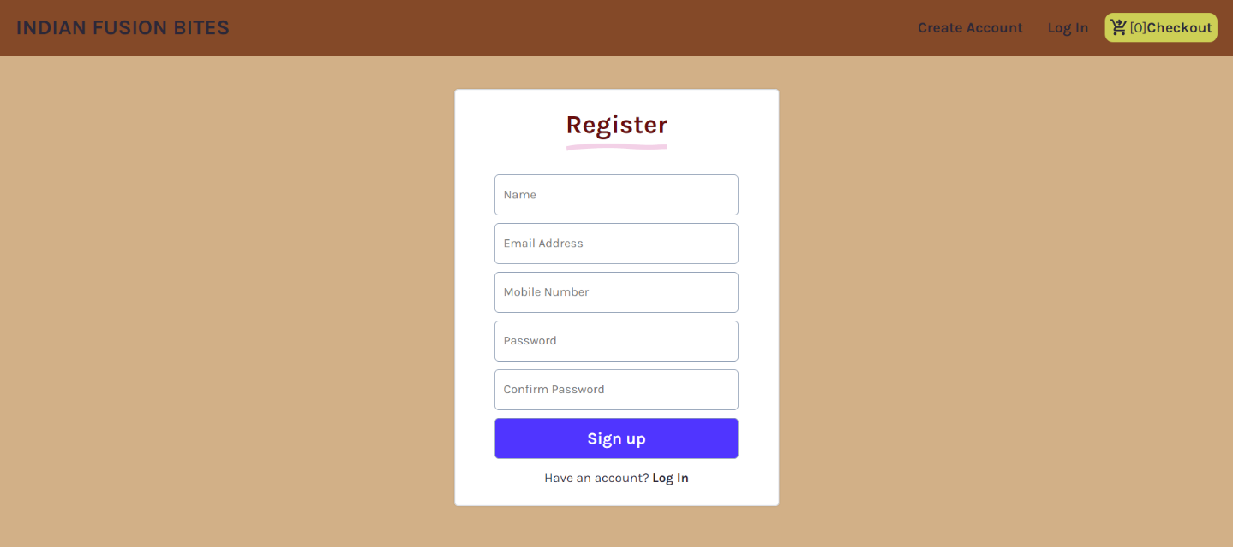

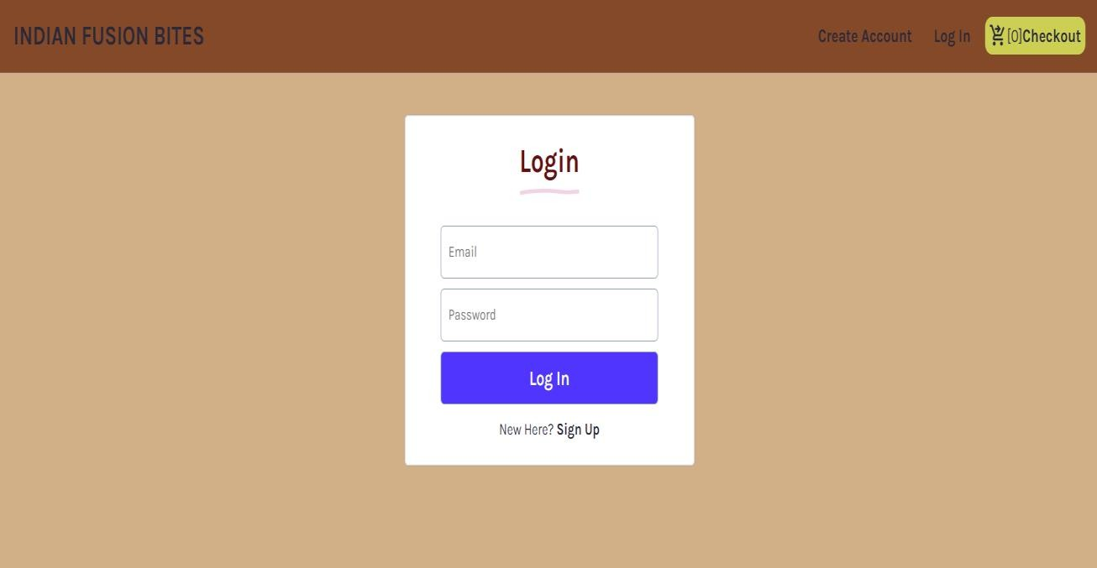

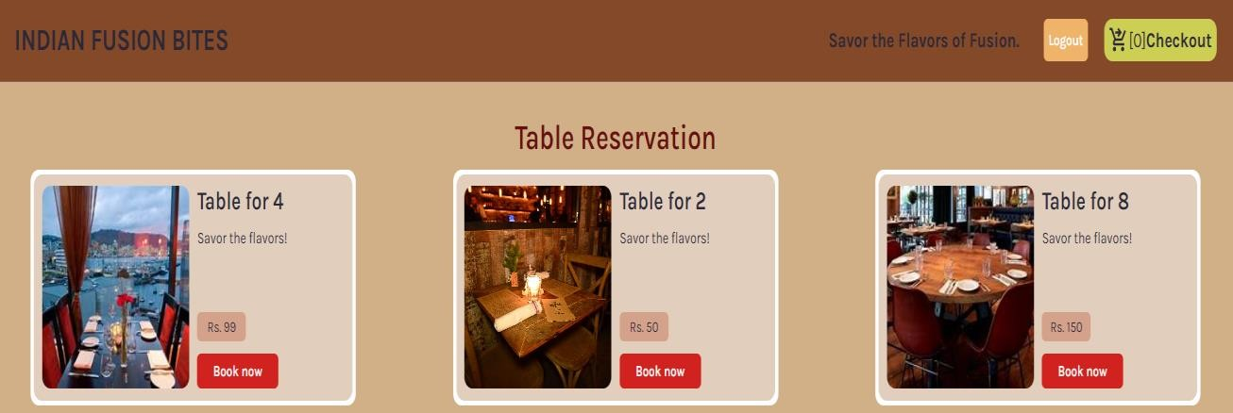

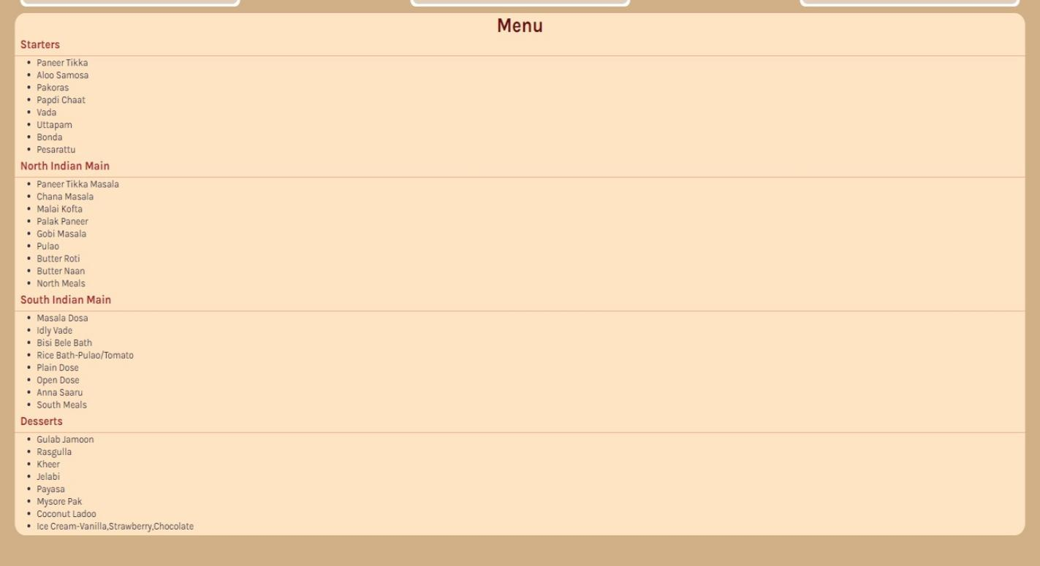

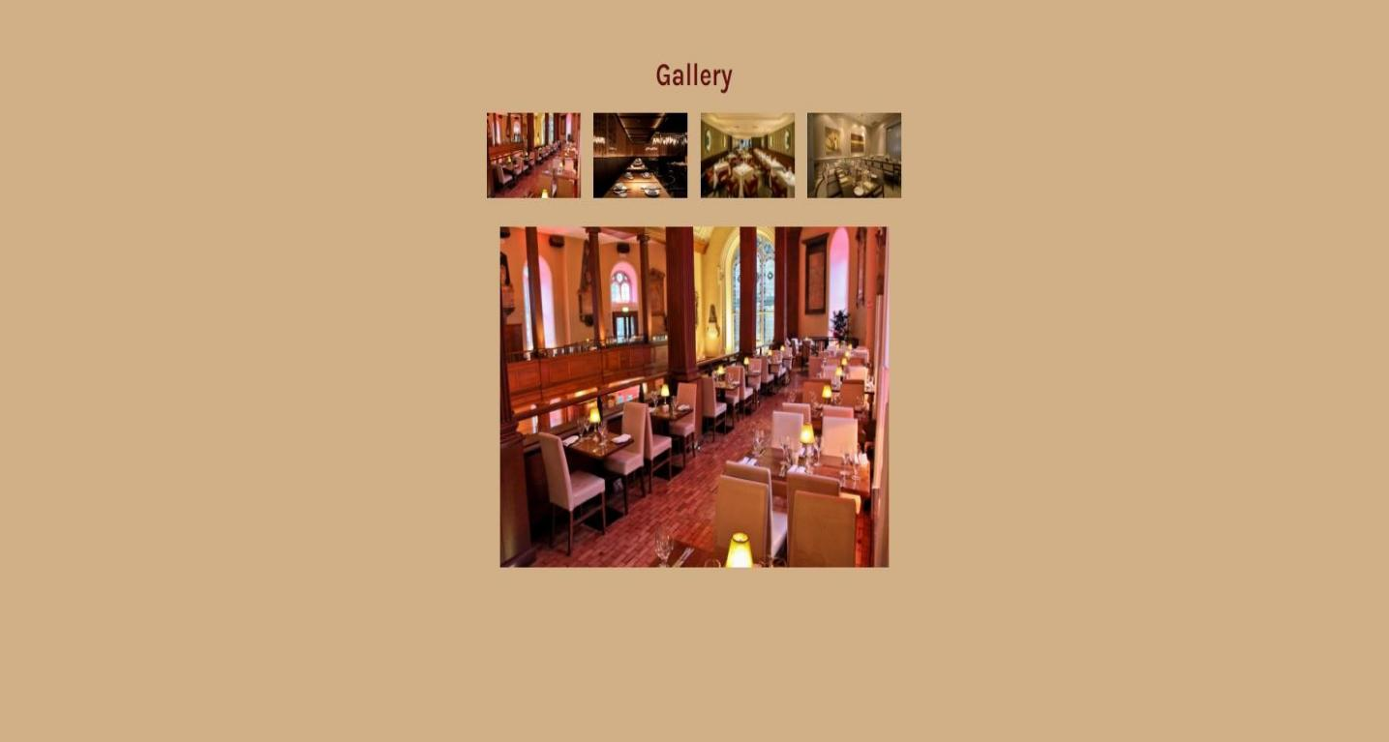

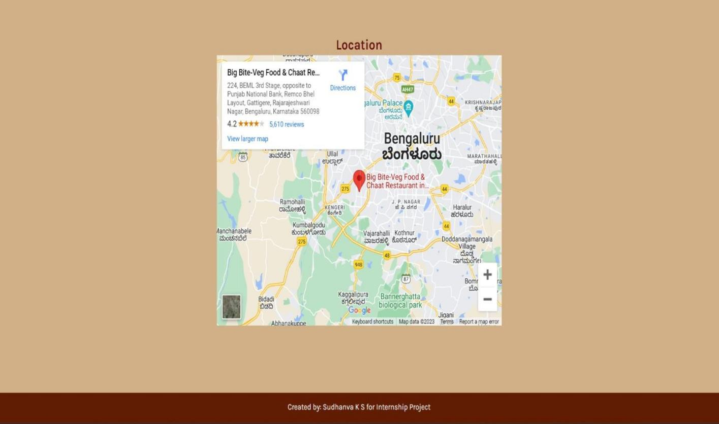

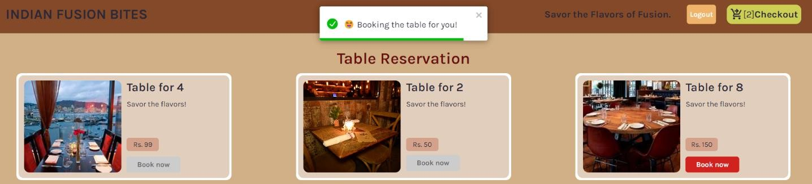

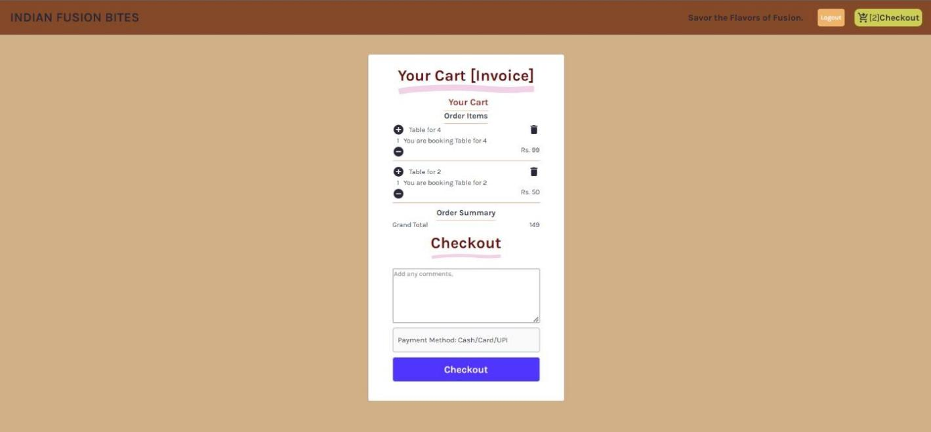

# Backend Snapshots

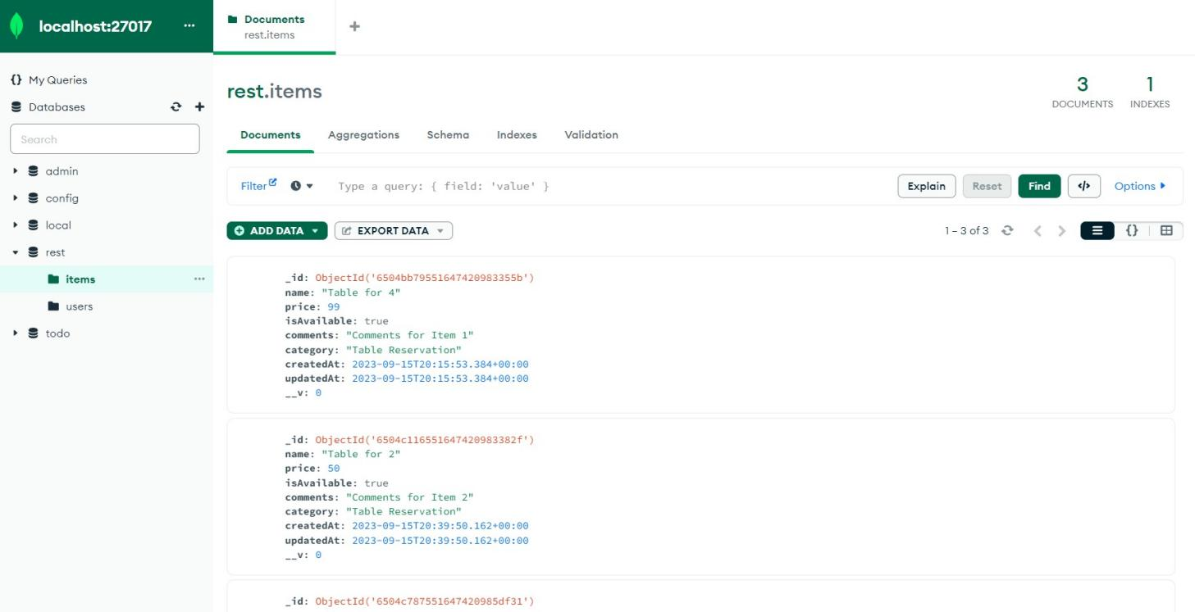

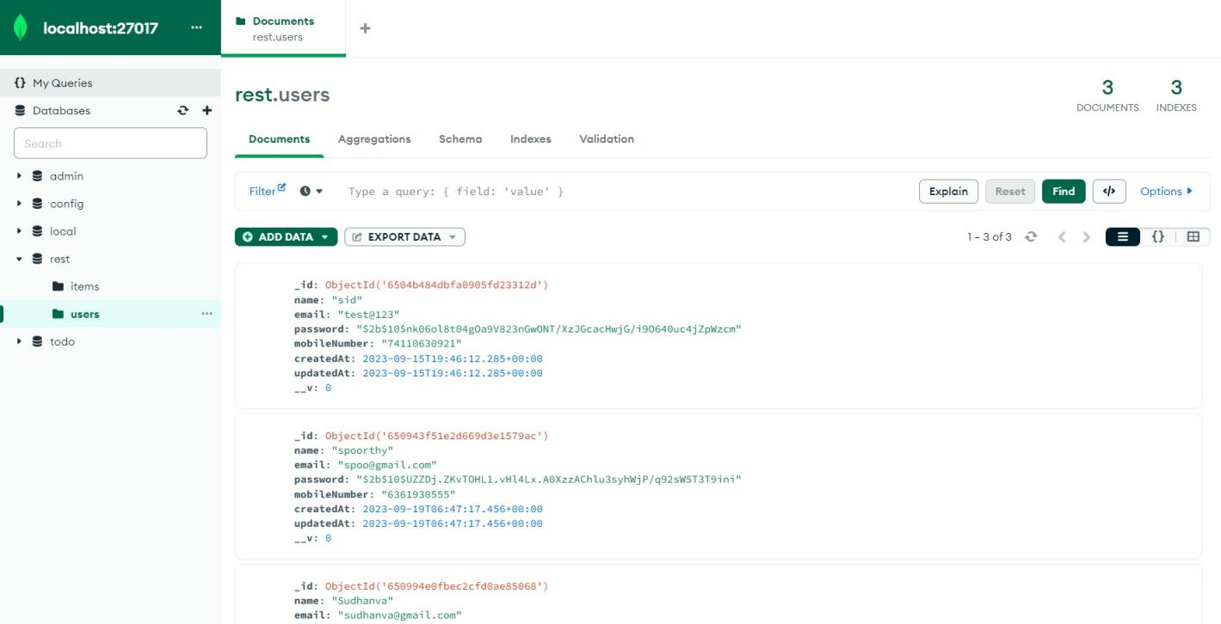

**[CHAPTE](https://1.bp.blogspot.com/-dODuK8N5h1Q/Wlnyb3V9HFI/AAAAAAAACL4/WxQtCJ1pM5wccDABg4wIrTBUB0vlikXQQCLcBGAs/s1600/poly1.jpg)R 8** **CONCLUSION**

# CONCLUSION

In conclusion, the development of this restaurant website template with its innovative features, such as an automated reservation system, efficient image loading, and mobile-friendly maps, holds great promise for the restaurant industry. This project not only addresses the common challenges faced by restaurants in the digital era but also provides a platform for enhanced customer engagement and streamlined operations. By elevating their online presence and offering a seamless user experience, restaurants can position themselves competitively in the market, ultimately leading to increased customer satisfaction and business success. This project marks a significant step toward modernizing the way restaurants interact with their patrons and showcases the potential for digital transformation within the industry.

# REFERENCE

1. <https://www.w3schools.com/css/>
2. <https://www.geeksforgeeks.org/>
3. <https://developer.mozilla.org/en-US/>
4. <https://www.npmjs.com/>
5. <https://www.mongodb.com/>